UNIT 1.3 / HUBS, BRIDGES, AND SWITCHES / STUDY NOTES

Objectives
On completion of this unit, you will be able to:
- Install and configure hubs, bridges, and switches.
- Understand the use of spanning tree to prevent switching loops.

Syllabus Objectives and Content Examples
This unit covers the following exam domain objectives and content examples:
- 1.3 Explain the concepts and characteristics of routing and switching.
Segmentation and interface properties (Port mirroring, Switching loops/spanning tree, PoE and PoE+ [802.3af, 802.3at], MAC address table)
- 2.2 Given a scenario, determine the appropriate placement of networking devices on a network and install/configure them.
Switch • Hub • Bridge
- 4.6 Explain common mitigation techniques and their purposes.
Switch port protection (Spanning tree, Flood guard, BPDU guard, Root guard)

Hubs and Bridges
Most Ethernet networks are wired in a physical star topology with each node connecting to the network via a central networking device, such as a hub, bridge, or switch. Hubs and bridges are no longer widely deployed as standalone appliances as their role has been taken on by more advanced devices (such as Ethernet switches). Nevertheless, it is important to understand what basic functions they perform.

Hubs
A hub is the central point of connection for 10BASE-T Ethernet segments configured in a physical star topology. Hubs act like a repeater so that every segment receives transmissions sent from any other segment; the logical topology is still a bus. Hubs are also known as multiport repeaters. They work at the physical layer of the OSI model.
A hub is internally wired with transmit (Tx) and receive (Rx) pairs for each port. The hub connects the nodes on the network as follows:
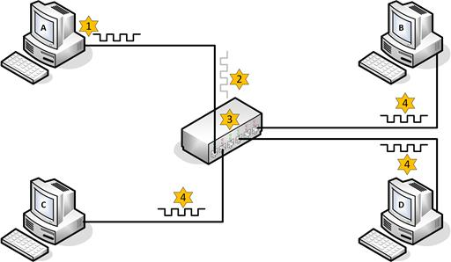
Using a hub to implement a physical star topology.
- Computer A sends a transmission using its Tx pair.
- The hub receives a weakened and distorted transmission at port 1 on its Tx pair.
- The hub regenerates the transmission, performs a crossover, and transmits the regenerated transmission out of all its other ports on the receive (Rx) pair.
- Computers B, C, and D receive the transmission on their Rx pairs.
All the ports on a hub are in the same collision domain and all communications are half-duplex.
Hubs can also be linked together using a special cable type called a crossover cable. This works as follows:
- Computer A sends a transmission using its Tx pair.
- Hub 1 receives a weakened and distorted transmission at port 1 on its Tx pair.
- The hub regenerates the transmission, performs a crossover, and transmits the regenerated transmission out of all its other ports on the receive (Rx) pair. One of these ports is connected to hub 2 via a crossover cable.
- Because hub 2 now receives the transmission on its Tx pair via the crossover cable, it regenerates the transmission, performs a crossover, and transmits it over the other five ports on the Rx pair.
- Computer B receives the transmission from hub 2 on its receive pair.
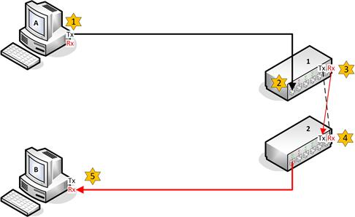
Crossover cable between cascading hubs.
Fast Ethernet is restricted to using two hubs within a single network, but this restriction does not apply to a switched network. Gigabit and 10GbE Ethernet require the use of switches. Hubs are obsolete for most practical purposes.

Bridges
An Ethernet bridge provides communications between two or more segments. Like a hub or repeater, a bridge can extendthe maximum distance of network, but it may also be used to segment the network. A network might be divided into two or more segments to reduce the number of collisions caused by having too many nodes. Bridges work at the data link layer since they need to parse the MAC addresses within frames. Segments on different bridge ports are in separate collision domains but the same broadcast domain.
A bridge works as follows:
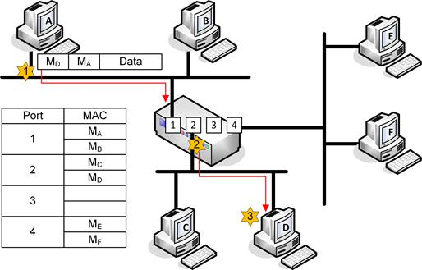
Bridge operation.
- Computer A sends a transmission to computer D. Note that the frame contains a source hardware address of M_{A} and a destination hardware address of M_{D}.
- The bridge listens to all traffic on all attached segments and consequently receives the transmission at port 1.
- The bridge reads the destination in the frame and, using its MAC address table, determines the port to which the network card with hardware address M_{D} is attached. The bridge is able to locate the hardware address M_{D} in its port:MAC address table and forwards the transmission out of port 2 only.
An Ethernet bridge builds the MAC address table in memory. When the bridge is initialized, the bridging table is empty but information is constantly added as the bridge listens to the connected segments. Entries are flushed out of the table after a period to ensure the information remains current.
- If no record of the hardware address exists or the frame is a broadcast or multicast, then the bridge forwards the frame to all segments except for the source segment (acting like a hub).
Most bridges are only able to link segments using the same frame type (for example, Ethernet to Ethernet) but can be used to link different segments with different cable types (such as coax and twisted pair).

Switches
Ethernet networks implemented with a bus or hubs rely on a contention-based technology for accessing the media. Nodes can only transmit on the network when it is free. These opportunities become less frequent as more devices are added to the network and the probability of collisions increases.
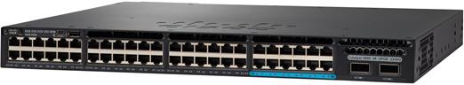
Cisco Catalyst 3650 Series workgroup switch. Image © and Courtesy of Cisco Systems, Inc. Unauthorized use not permitted.
These problems can be overcome by moving from this shared Ethernet system to switched Ethernet. This move involves the replacement of hubs and bridges with switches. Switches have now almost completely replaced legacy devices such as hubs and bridges. The use of switches is mandatory for Gigabit Ethernet and Ethernet 10GbE.

Switch Operation
An Ethernet switch performs the same sort of function as a bridge but can provide many more ports (bridges only came with up to 4 ports). Each switch port is a separate collision domain. In effect, the switch establishes a point-to-point link between any two network nodes. This is referred to as microsegmentation. This works as follows:
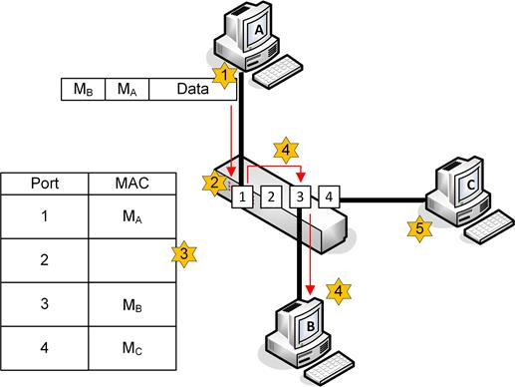
Switch operation.
- Computer A transmits a frame intended for Computer B.
- The switch receives the frame into a port buffer and reads the destination MAC address from the Ethernet frame. The port buffer holds frames until they can be processed. The switch can also perform error checking on the frame using the CRC.
- The switch uses its MAC address table to look up the port connected to the destination MAC address.
- The switch uses its high-speed backplane to send the frame out on port 3 for computer B to receive (creating a temporary virtual circuit).
- None of the other connected devices (such as computer C) see any activity on the network while this process takes place. Therefore, these other devices are able to transmit and receive at the same time.
Because each port is in a separate collision domain, collisions can only occur if the port is operating in half-duplex mode (if a legacy network card or a hub is attached to it for instance). Even then, collisions only affect the segment between the port and that adapter; they do not slow down the whole network. As with a bridge though, traffic on all switch ports is in the same broadcast domain, unless the switch is configured to use Virtual LANs (VLAN).
See Unit 4.3 / Network Security Design / Study Notes for more information about VLANs. There are many types of switches other than Ethernet switches (or "basic switches"). Some are used to implement WANs (ATM and SONET switching for instance), and some are used to forward traffic at OSI layers 3 and above. The functions of these "multilayer switches" are covered in Unit 4.1 / Applications and Services / Study Notes.

MAC Address Table
If a MAC address cannot be found in the MAC address table then the switch acts like a hub and transmits the frame out of all the ports (except for the incoming port). This is referred to as flooding. The switch builds the MAC address table by analyzing incoming frames for a source MAC address. It can then add a MAC address entry against the particular port number. Entries remain in the MAC address table for a period before being flushed. This ensures problems are not encountered when network cards (MAC addresses) are changed. The address table is implemented as Content Addressable Memory (CAM), a special type of memory optimized for searching rather than random access. Consequently, the MAC address table is often also referred to as the CAM table.
You can query the MAC address table of a switch to find the MAC address or addresses associated with a particular port using a command such as:
show mac address-table
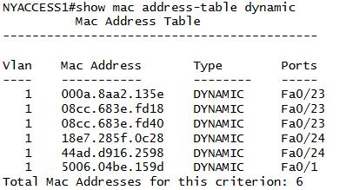
Displaying dynamic entries in the MAC address table of a Cisco switch.
The MAC address table is NOT the same as an ARP table. A MAC address table maps known MAC addresses to interface ports on the switch. An ARP table is maintained by a layer 3 device to cache known MAC address to IP address mappings. Refer back to Unit 1.2 / Ethernet / Study Notes for more information about ARP.

Switch Models
Switches from different vendors come in a variety of different ranges to support various sizes of networks. While a basic model might feature 12-48 ports and little scope for expansion, advanced switches support interconnections via high speed backplanes and expandable capacity through plug-in modules plus power supply redundancy, management consoles, and interface converters for fiber optic connectivity.
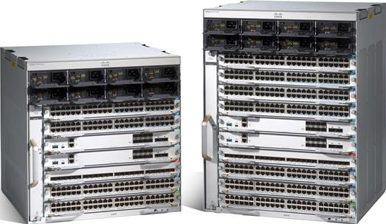
Cisco Catalyst 9400 Series modular chassis allow provisioning multiple access switches. Image © and Courtesy of Cisco Systems, Inc. Unauthorized use not permitted.
The market is dominated by Cisco's Catalyst series (over 55% of sales by port), but other notable vendors include HP Enterprise, Huawei, Juniper, and Arista.

Switch Interface Configuration
An unmanaged switch can be plugged in, turned on, and left to do its job. Most switches are managed however. Configuration can either be performed over a web interface or some sort of command line. Once you have established a connection to the switch's management interface, you can configure settings for each of the switch port interfaces. These settings control the network link configured for each client device attaching to the switch.

Speed and Duplexing
Switches normally support a range of Ethernet standards so that older and newer network adapters can all be connected to the same network. In most cases, the port on the switch is set to autonegotiate speed (10/100/1000) and full or half-duplex operation. A static configuration can be applied manually if necessary.
See the section on troubleshooting in Unit 3.5 / Network Troubleshooting / Study Notes for more information about solving problems with switch port configurations.
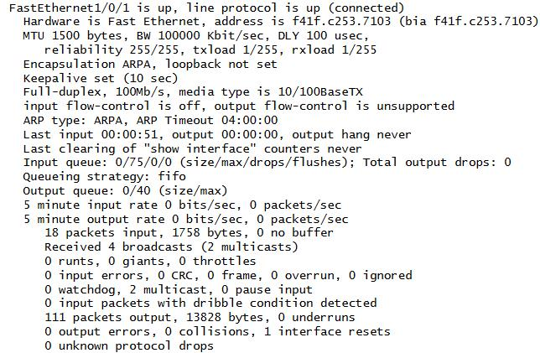
Viewing interface configuration on a Cisco switch.

IP Address Assignment and Default Gateway
An IP address is used to identify a host at layer 3 of the OSI model. Normally, when a host connects to a port it will connect to a network where an autoconfiguration service called the Dynamic Host Configuration Protocol (DHCP) will enable the host to obtain a valid IP address and other network configuration information, such as the address of a default gateway (or router) that can be used to connect to other networks.
In some circumstances you might want to configure the switch to assign an IP address to hosts connecting to that port. You can do this if the switch comes with its own internal DHCP server. This sort of configuration might be useful for smaller networks.
See Unit 2.4 / DHCP and APIPA / Study Notes for more information about IP address autoconfiguration and DHCP.

Port Mirroring
Unlike a hub, a switch forwards unicast traffic only to the specific port connected to the intended destination interface. This prevents sniffing of unicast traffic by hosts attached to the same switch. There are circumstances in which capturing and analyzing network traffic is a legitimate activity, however, and port mirroring provides the facility to do this. Port mirroring copies all packets sent to one or more source ports to a mirror (or destination) port. On a Cisco switch, this is referred to as a Switched Port Analyzer (SPAN).
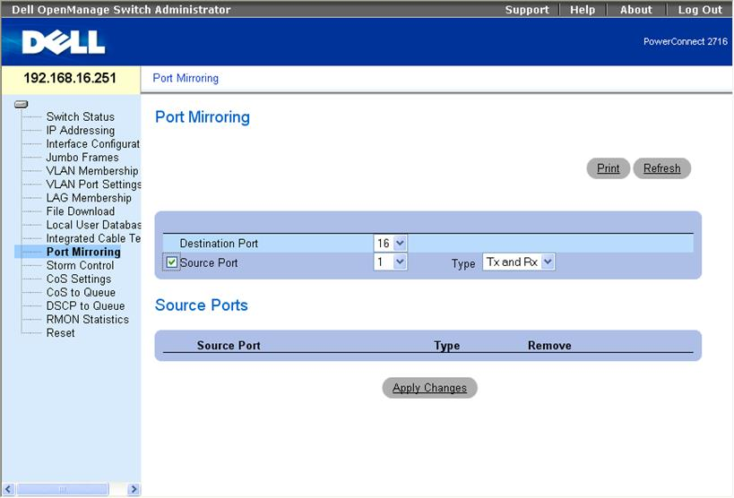
Configuring port mirroring on a Dell switch.
The mirror port would be used by management or monitoring software, such as a Network Analyzer or Intrusion Detection System (IDS). Either ingress or egress traffic or both can be captured. Optionally, in order to avoid overloading the monitoring system, packets may be filtered based on criteria such as protocol ID or TCP/UDP port number.
The above describes local port mirroring where the source and destination ports are on the same switch. On advanced switches, it is possible to perform remote port mirroring by making the destination port a port on another switch.
Port mirroring demands a lot of processing and can lead to the switch hardware becoming overloaded and consequently crashing. If possible, trial any security solution that requires port mirroring under typical loads before deploying it on a production network.

Spanning Tree Protocol (STP)
In a network with multiple bridges (implemented these days as switches), there may be more than one path for a frame to take to its intended destination. Multiple paths are part of good network design as they increase resilience; if one link fails, then the network can remain operational by forwarding frames over a different path. As a layer 2 protocol, Ethernet has no concept of Time to Live. Therefore, layer 2 broadcast traffic could continue to loop through a network with multiple paths indefinitely. Layer 2 loops are prevented using the Spanning Tree Protocol (STP), defined in the IEEE 802.1D MAC Bridgesstandard.

Topology Change Notifications
Spanning tree is a means for the bridges to organize themselves into a hierarchy. The bridge at the top of the hierarchy is the root bridge. The switch with the lowest bridge ID (comprised of a priority value and the MAC address) will be selected as the root. An administrator can set the priority value to make the choice of one bridge over another more likely. The root bridge will usually be part of a high bandwidth backbone or core switch group; performance will suffer if a switch on a low bandwidth segment becomes root.
Each bridge then determines the shortest path to the root bridge by exchanging information with other bridges. This STP information is packaged as Bridge Protocol Data Unit (BPDU) multicast frames. A port that forwards "up" to the root bridge, possibly via intermediate bridges, is identified as a root port. Ports that can forward traffic "down" through the network with the least cost are identified as designated ports. A port that would create a loop is identified as a blocking ornon-designated port. Subsequently, bridges exchange Topology Change Notifications if devices are added or removed, enabling them to change the status of forwarding/blocked ports appropriately.
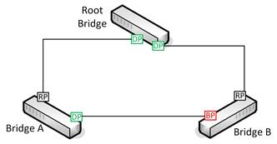
STP configuration.
The diagram above shows the minimum configuration necessary to prevent loops in a network with three bridges or switches. The root bridge has two designated ports (DP) connected to Bridge A and Bridge B. Bridges A and B both have root ports (RP) connected back to the interfaces on the root bridge. Bridges A and B also have a connection directly to one another. On Bridge A, this interface is active and traffic for Bridge B can be forwarded directly over it. On Bridge B, the interface is blocked (BP) to prevent a loop, and traffic for Bridge A must be forwarded via the root bridge.
The following table shows the different states that a port can be in:
State | Forwards Frames? | Learns MACs? | Notes
Blocking | No | No | Drops all frames other than BPDUs.
Listening | No | No | Port is listening for BPDUs to detect loops.
Learning | No | Yes | The port discovers the topology of the network and builds the MAC address table.
Forwarding | Yes | Yes | The port works as normal.
Disabled | No | No | The port has been disabled by the administrator.
When all ports on all bridges are in forwarding or blocking states, the network is converged. When the network is not converged, no communications can take place. Under the original 802.1D standard, this made the network unavailable for extended periods (10s of seconds) during configuration changes. STP is now more likely to be implemented as 802.1D-2004/802.1w or Rapid STP (RSTP). The rapid version creates outages of a few seconds or less. In RSTP, the blocking, listening, and disabled states are aggregated into a discarding state.
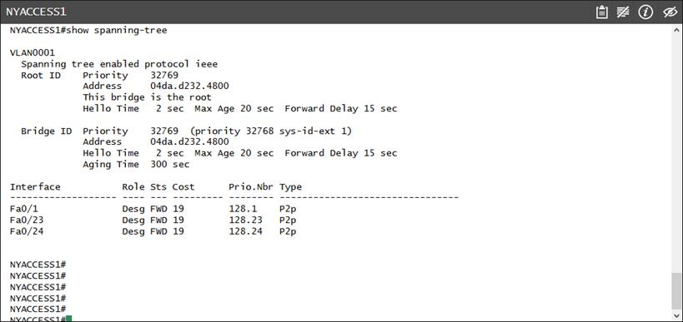
Viewing spanning tree configuration on a Cisco switch.

Flooding
A switch keeps a cache of MAC addresses associated with each port to enable it to forward traffic quickly. This cache is periodically flushed to ensure it is up to date. When the switch does not know the correct port to use for a particular destination MAC address (if the cache has just been flushed for instance), it floods the frame out to all ports, even if the frame is unicast and not broadcast. Topology changes in STP (and especially RSTP) can cause a switch to flush the cache more frequently and to start flooding unicast traffic more frequently, which can have a serious impact on network performance.
To minimize the effects of unicast flooding, ensure that access ports (a port used to connect a host computer) are excluded from topology change notifications. Configuring port fast on a port causes it to always skip the listening and learning states.

Filtering STP Traffic
In some circumstances you might want to prevent a switch port from using STP. Some commands that can be used to filter STP traffic include:
- BPDU Guard - this causes a port configured with port fast that receives a BPDU to become disabled. BPDUs are not expected on access ports so this protects against misconfiguration or a possible malicious attack.
- BPDU Filter - this causes the port to drop all BPDUs. This could cause traffic to loop if used improperly. You might configure this on a link between two separately administered switching fabrics or use it when joining physical and virtual switch fabrics.
- Root Guard - this setting means that a switch will not accept attempts from switches connected to the guarded port to become the root. For example, you might have a group of high-performing "core" switches from which you want the root bridge to be selected. Low-performing access switches would be connected to these "downstream"; they still need to participate in STP but should not be able to become the root. Using root guard would prevent a misconfiguration or malicious traffic from making a "downstream" switch or rogue host become root.
See Unit 4.2 / Virtualization, SAN, and Cloud Services / Study Notes for more information about virtual switches. Note that a virtual switch is different from a virtual LAN. Also note that the principal virtual switch vendor (VMware) implements a BPDU Filter feature (dropping STP traffic without disabling the port) but call it BPDU Guard.

Broadcast Storms and Flood Guards
Switching loops cause broadcast frames to circulate the network perpetually. However, unlike IP routing loops, there is no TTL for layer 2 frames. Such loops at the data link layer can cause what are often called broadcast storms. A broadcast storm may quickly consume all link bandwidth and crash network appliances (check for excessive CPU utilization on switches and hosts).
The Spanning Tree Protocol is supposed to prevent such loops, but this can fail if STP communications between switches do not work correctly, either because of a fault in cabling or a port / transceiver or because of a misconfiguration. Examples include connecting a single patch cable to two switch ports or bridging the wired and wireless adapters on a connected host.
Most switches come with storm control or flood guard settings that can be used to automatically shut down a port that is receiving an unacceptable number of broadcast frames. Alternatively, if the network is still operational you may be able to use a network sniffer to identify the source of the loop. Otherwise, you may have to physically disconnect cables to identify the culprit.
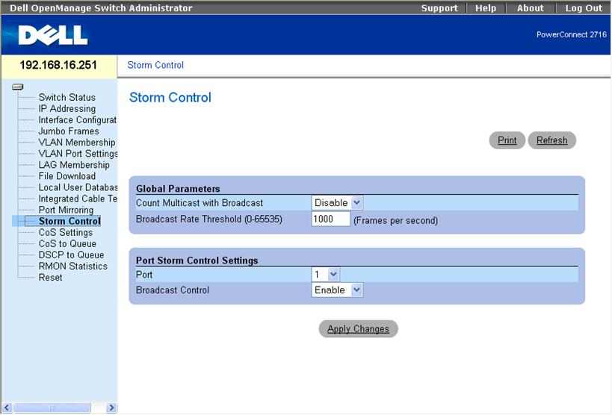
Configuring broadcast storm control settings on a Dell switch

Power over Ethernet (PoE)
Power over Ethernet (PoE) is a means of supplying electrical power from a switch port over ordinary data cabling to a connected powered device, such as a VoIP handset or wireless access point. PoE is defined in two IEEE standards (now both rolled into 802.3-2012):
- 802.3af - powered devices can draw up to about 13W over the link. Power is supplied as 350mA@48V and limited to 15.4W but the voltage-drop over the maximum 100 feet of cable results in usable power of around 13W.
- 802.3at (PoE+) - powered devices can draw up to about 25 W, with a maximum current of 600mA. Note that various proprietary schemes were used prior to the ratification of 802.3at.
PoE switches are referred to as endspan (or endpoint) Power Sourcing Equipment (PSE). If an existing switch does not support PoE, a device called a power injector (or midspan) can be used. Power can either be supplied over pairs 1/2 and 3/6 (referred to as Mode A or phantom power, as these are the ones also used for data in 10/100BASE) or over 4/5 and 7/8 (Mode B). Gigabit Ethernet only uses the former method.
When a device is connected to a port on a PoE switch, the switch goes through a detection phase to determine whether the device is PoE-enabled. If not, it does not supply power over the port and therefore does not damage non-PoE devices. If so, it determines the device's power consumption and sets the supply voltage level appropriately.
Powering these devices through a switch is more efficient than using a wall-socket AC adapter for each appliance. It also allows network management software to control the devices and apply schemes, such as making unused devices go into sleep states and power capping.

